`

Department of Mechanical Engineering

EMCH 368
MECHATRONICS

Lab 01
Introduction to Microcontrollers and Circuits

Last Edited: 6/25/2024 by T. Russo

Expectations
- Your TAs are not here to write the code or fix your circuits for you. Imagine this lab as a job, you cannot run to your boss (TA’s) whenever you run into problems, to succeed in this lab and in future employment you must be able to locate, debug, and solve your own errors. It is encouraged of you to ask for help from your peers before coming to your TA if you're unable to locate the issue yourself. If you have any questions or run into any errors with your code, even after following the steps expected of you, then do not be afraid to ask for help. This is expected of you before you ask for help.
  - Have you checked your circuit?
  - Have you used the Oscilloscope or Multimeter to check for voltage, current, and resistance?
  - Have you checked for any spelling errors, missing variables, semicolons, or brackets?
  - Have you checked to see if your code is working? (Using Serial.print() for confirmation throughout)
  - Have you looked up the output error online?
  - Have you asked for help from your peers?
- You will notice that almost all code is given for these exercises. However, this will not be the case as you progress through the weeks. This is seen in exercise 4, which includes no code and is entirely up to you to code. It will be expected of you to be able to code any situation that is given based off what you learn from these labs.

Tools

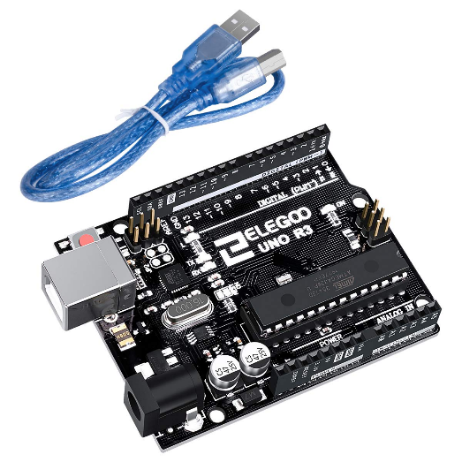
For this lab, we will be using the ELEGOO UNO board. This is a microcontroller which you learned about during lectures. Major parts to note on this board are the USB port on the top right, the 5V, ground, and analog pins located on the left edge, and the digital input/output pins along the right edge. Some of the digital pins have squiggly lines next to the number. This indicates they are for PWM use which will be explained more on in later labs / lectures. This microcontroller runs on the ATmega328P microprocessor.

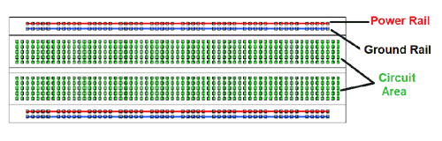

The breadboard is the primary place you will be building circuits. This breadboard is solderless, meaning that the components can easily be placed onto and removed from the breadboard without soldering. On the breadboard, there are vertical metallic strips that run the length of the board as seen in the picture as the power and ground rails. These are usually where power (+) and ground (-) are connected.
The 5 holes in each horizontal row are connected by metal strips. The gap between the rows of 5 holes breaks the connection between the two sides of the board. Of course, the two sides could simply be wired together if needed.

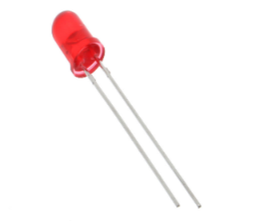
An LED, or light-emitting diode, is a component that converts electrical energy into light energy. LEDs are polarized components, which means they only allow electricity to flow through them in one direction. The longer leg, called the anode, is connected to power while the short leg, called the cathode, is connected to ground. When current flows from the anode and cathode, the LED emits light. In general the LEDs need at least a 220-ohm resistor, or they will burn out

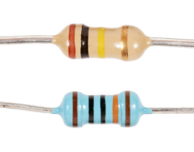
A resistor is a component that resists the flow of electrical energy. Some of this electrical energy gets transformed into heat energy. When a resistor is put in series with an LED, for example, it uses some of the electrical energy, and the LED receives less energy. Resistors allow you to manipulate the amount of energy supplied to each component, which is useful since not all components require the same amount. In the case of the LED, it would receive too much current without a resistor and quickly burn out.

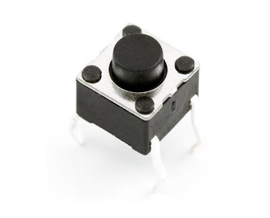
A switch interrupts the flow of electricity, breaking the circuit when open. When a switch is closed, it will complete a circuit. There are many types of switches. The ones in your kit are called momentary switches, or pushbuttons, because they are only closed when pressure is applied.

Familiarize yourself with your ELEEGO Kit
You are receiving the ELEGOO Starter Kit. This kit comes with everything you need to learn the fundamentals of circuit design. Take a moment to look through the kit and discover what is all included in your box. The components are stored in separate sections and there should be a list with pictures of what each item is. Be sure to take care of all your components and return them to the proper sections when you are finished with each lab so that you stay organized. Be aware that the term ARDUINO may be used interchangeably with ELEEGOO in reference to the microcontroller.

Exercise 1: Building Your First Circuit
You are going to use the ELEGOO for this exercise, but only as a source of power. When plugged into a USB port or a 9-volt battery, the ELEGOO will provide 5 volts between its 5V pin and its ground pin that you can use. NOTE: Whenever you are building/deconstructing your circuit, make sure the power supply is UNPLUGGED.

Materials:
- 1 set of long red and black jumper wires
- 1 220-ohm resistor
- 1 LED

Building the Circuit:
- Connect a red wire to the 5V pin on the ELEGOO and put the other end in one of the long (+) bus lines in the breadboard.
- Connect a black wire to the ground pin on the ELEGOO to the adjacent long (-) bus line on the breadboard.
- Use a 220-ohm resistor to connect power from the (+) bus to one of the rows and connect the light's anode to that same row in the prototyping area.
- Connect the cathode (short leg) of the LED to a hole in a different row and ground the cathode to the (-) bus.
- Connect the ELEGOO to power by connecting it to your computer through USB. The light should turn on!

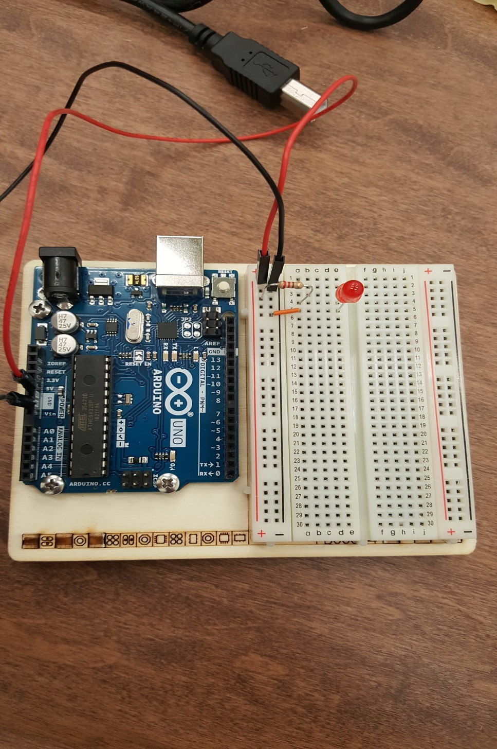
Exercise 1 Circuit

Exercise 2: Making an Interactive Circuit
In this exercise, you will be creating an interactive circuit by adding a switch.

Materials:
- 1 set of long red and black jumper wires
- 1 220-ohm resistor
- 1 red LED
- 1 switch

Building the Circuit:
- Remove the USB power supply before tampering with the circuit.
- Remove the LED and its ground connection in the circuit you made in the previous exercise.
- Add the switch to the row containing the 220-ohm resistor. Place the switch across the center of the breadboard. The bend in the legs of the switch should point towards the center of the board.
- Connect the anode (long leg) of an LED to the bottom part of the switch. Ground the cathode (short leg) of the LED.
- Connect the USB power and observe what happens. What happens when you press the button? What happens when you hold down the button?
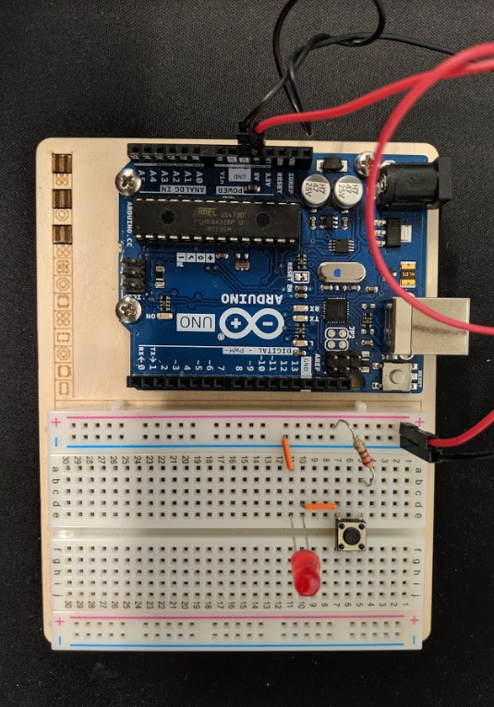
Exercise 2 Circuit

Exercise 3: Series vs. Parallel Circuits
In this exercise, you will create two different circuits that demonstrate the principles of having components connected in series versus being connected in parallel.
Materials:
- 1 set of long red and black jumper wires
- 1 220-ohm resistor
- 1 red LED
- 2 switches
Part A - Building the Circuit:
- Remove the USB power supply before tampering with the circuit.
- Remove the LED and its ground connection in the circuit you made in Exercise 2.
- Add another switch to the circuit and connect them directly.
- Connect the anode (long leg) of an LED to the other side of the new switch and ground the cathode (short leg).
- Connect the USB power supply and observe what happens. What happens when you press either button? What happens when you press both? Is this a series or a parallel circuit? Get the TA to check your work.
Part B - Building the Circuit:
- Remove the USB power supply before tampering with the circuit.
- Remove the wire connecting the two switches
- Connect a wire from one side of the 220-ohm resistor to the top pin of the lower switch
- Connect a wire from the bottom pin of the upper switch to the anode (long leg) of the LED
- Connect the USB power supply and observe what happens. What happens when you press either button? What happens when you press both? Is this a series or a parallel circuit? Get the TA to check your work.
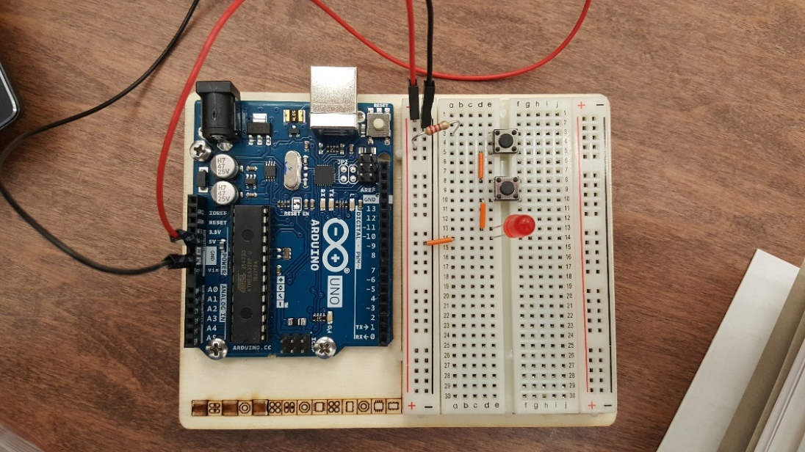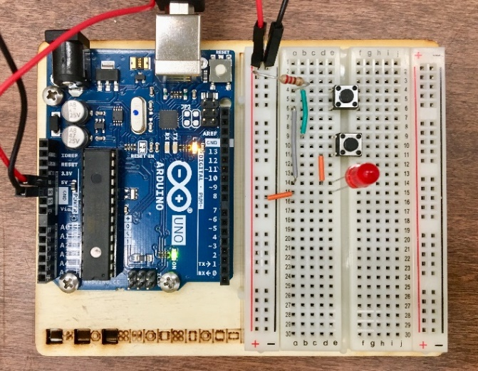
Exercise 3 : Part A Circuit Exercise 3 : Part B Circuit

Exercise 4: Creating an Interface with Custom Outputs
Now that you have learned some of the basics of electrical circuits, it is time to learn how to control your circuit with your microcontroller. In this exercise we will explore having both digital inputs and outputs and programming your circuit to perform custom tasks. Your goal is to create a circuit that meets the following criteria:
- A green light will be on until the user presses a button
- When the button is pressed, the green light will turn off and two red lights will start blinking
- The red lights must clearly blink alternatively from one another
- When the button is released, the red lights stop blinking and the green light turns back on
Materials:
- 1 set of long red and black jumper wires
- 3 220-ohm resistor, 1 10k-ohm resistor
- 2 red LEDs and 1 green LED
- 1 switch
Building the Circuit:
- Reset your breadboard.
- Begin by making sure your red jumper wire is connected to the 5V pin and the (+) power bus on the breadboard. The black jumper wire should be connected to the ground pin and the (-) bus on the breadboard.
- Place two red LEDs and one green LED to the breadboard. Attach each cathode (short leg) to ground with a 220-ohm resistor.
- Connect the anode (long leg) of the green LED to digital pin 3 on the right side of the microcontroller. Connect the red LEDs to pins 4 and 5, respectively.
- Place a switch across the center divider of the board. Connect one side to power (+) and the other side to digital pin 2. Also, ground the side of the switch connected to the microcontroller with a 10k-ohm resistor.
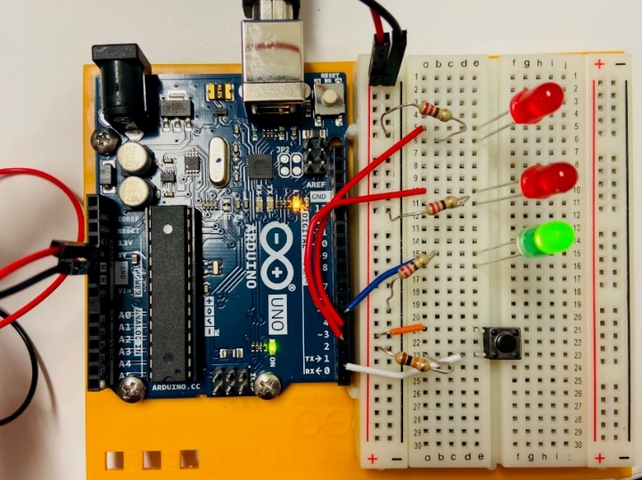
Exercise 4 Circuit
Writing the Code:
From here on out, we will be controlling our circuit by having the microcontroller read various inputs and then tailor its outputs to meet the criteria of our circuit’s design. The software has its own coding language, and these coding files are called “sketches.” The code is broken down step by step below, but for information on specific functions (e.g., what arguments they take) see the appendix at the end of each set of lab instructions.

Begin by opening the Arduino IDE software on your computer. This interface should appear:

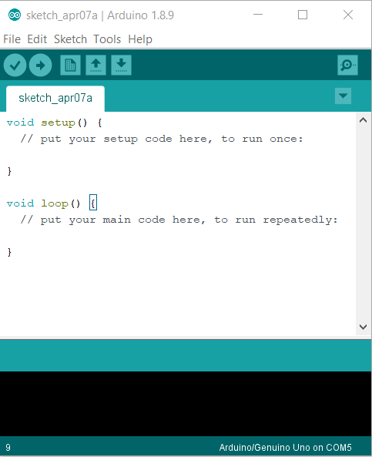

If there is already code written when you open the program, begin a new sketch.

Let us get coding!

This integer type variable is used to store the state of the circuit’s pushbutton, on or off. If the pushbutton is closed or on, a 1 is stored in this variable. If the pushbutton is open, a 0 is stored in this variable. When we create a variable, we must also give it an initial value. Any variables declared before void setup() are global variables which means they can be accessed anywhere in the future of your code. To display the line numbers on the left, go to File > Preferences > “Display Line Numbers”

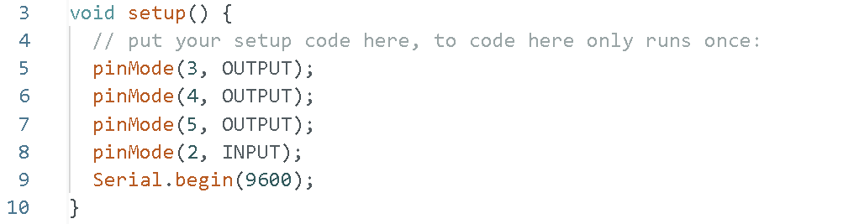
In this setup portion of the code, the digital pins used are configured as either inputs to be read by the microcontroller or as outputs for which the microcontroller will apply a voltage under certain conditions. For future reference, this same function is used for setting up analog pins as either outputs or inputs as well.
The Serial.begin(9600) command opens serial communication between the microcontroller and programming computer that allows the microcontroller to report values from the input pins. The number 9600 is in units of “baud” which is a unit of data transmission/reception rate.
Note that you can write comments by putting // anywhere in your code. Anything written after the // on that line will be ignored by the ELEGOO, so they are just for your benefit. Comments are a wonderful way to write out in words what your code is doing. You should make a habit of writing comments for each logical step in your code so that you can keep track of what is going on.

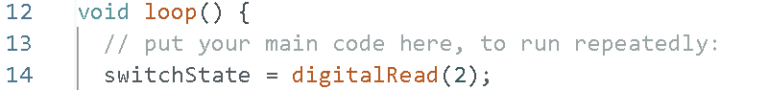

The main part of the code will be placed in the void loop() function. The variable switchState is set to become whatever value is returned from reading of digital pin 2. When the switch is closed, digitalRead(2) should go to HIGH. When the switch is open, it should return LOW.

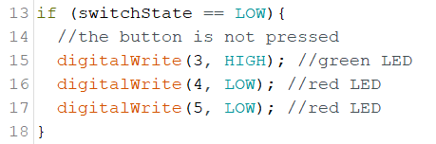

This if statement uses the reading from digital pin 2 to apply/remove voltages to the other pins. If the switch is open, a voltage will be applied to pin 3 and not to pins 4 and 5.

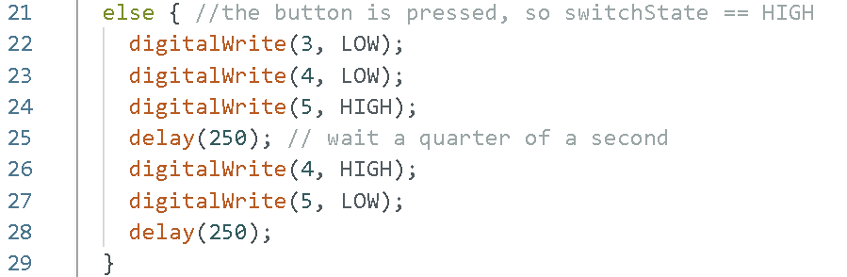
The else() statement declares what happens if the original if() statement’s criteria are not met. In this case, what happens when the switch is closed? The green LED is turned off (pin 3 is set to LOW) and one of the red LEDs is turned on (pin 5 is set to HIGH). One of our design criteria stated that the light must alternate from one another. Introduce a delay of 250-milliseconds into the system. After the delay, turn off the illuminated LED and turn on the opposite red LED. Put another 250-millisecond delay into the system.
At the end of the void loop(), is Serial.print() and Serial.println(). If you remember, at the beginning, we did Serial.begin which opened communication between the microcontroller and the computer. Serial.print() and Serial.println() are used to send information back to the computer from the microcontroller. This information can be seen in the Serial Monitor. In this code instance, we use Serial.print() to first send some text. Then, we use Serial.println() to send variable information, but unlike Serial.print(), it will also start a new line inside of the Serial Monitor.
To see the Serial Monitor, click this button  in the top right corner of the program. When you run the code on the microcontroller, you should see this inside of the Serial Monitor:
The switchState is: 0
To check the code for errors, select the Verify button at the top of the display as shown below.

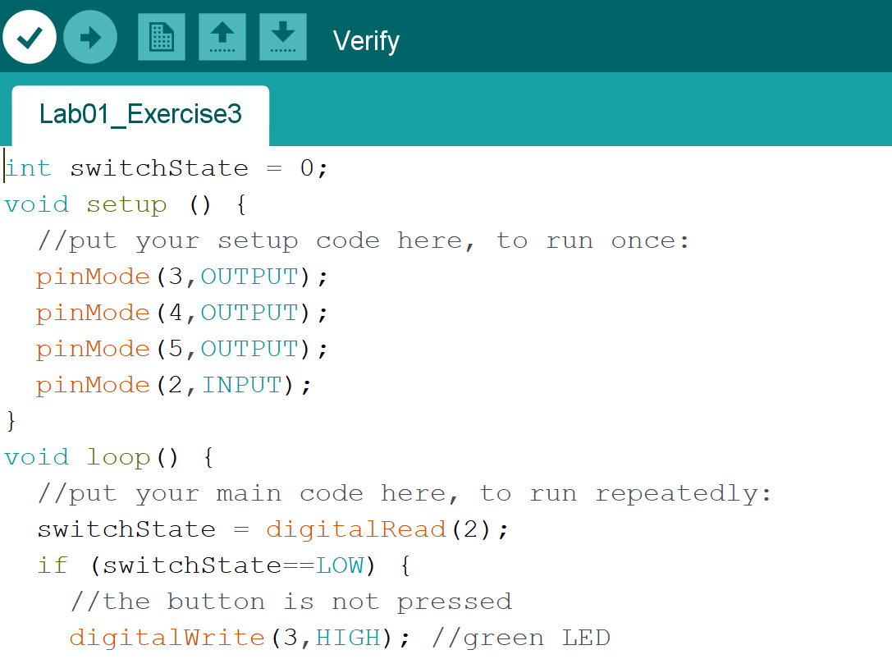

Once the code is free of errors, select the Upload button to submit the code to the circuit.

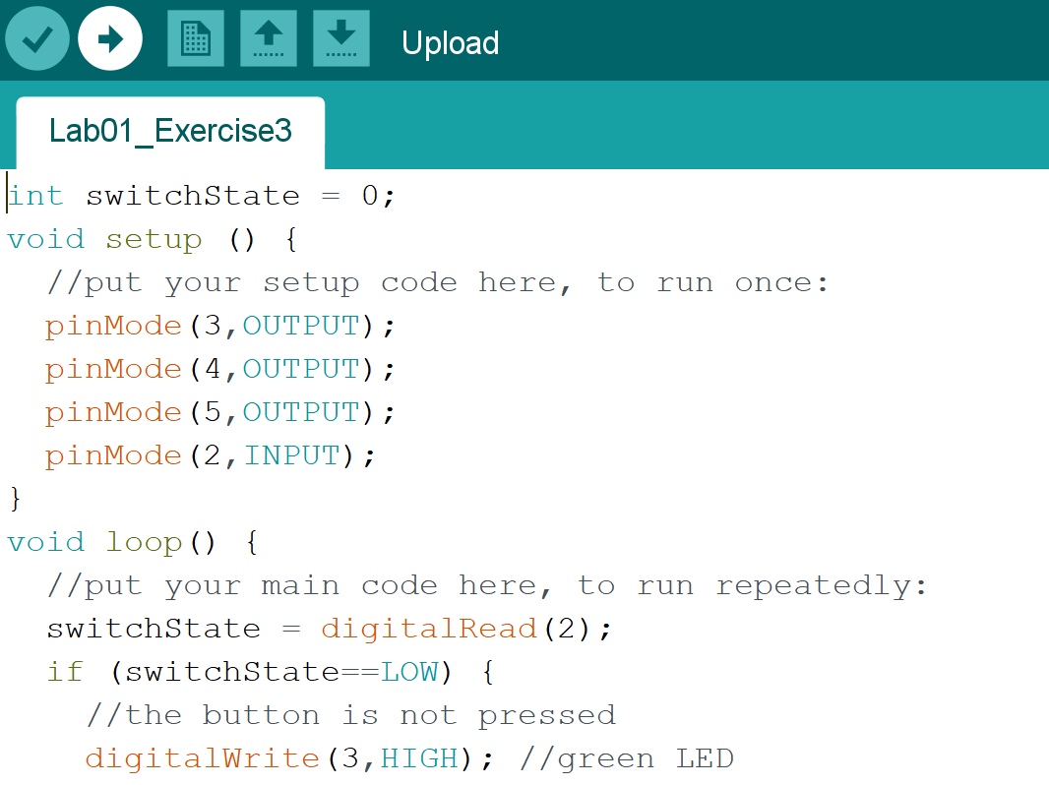

Challenge 1: Traffic Light
This is your first Challenge Question. Challenge questions may ask you to create a circuit, code, or both by yourself using what you have learned so far. Expectations, list of materials, or certain pieces of codes may be given.
For this challenge, you are to create an intersection that has two traffic lights for two directions. Each traffic light must resemble its real-life counterpart with Green, Yellow, and Red LEDs. Your system must have these requirements. Using this image as an example, if it's been 3 seconds since the traffic light in the flow of direction of the green car has started, then those lights will turn red and the lights for the silver car will turn green. We recommend using millis() function to determine the time. Millis() holds how long the Arduino has been on since powered on or reset. Below is a sketch that contains comments to help guide you on doing this challenge question. It is understood how difficult this first challenge question is due to the lack of experience but as you go through these labs, it will seem easy when you look back at it.


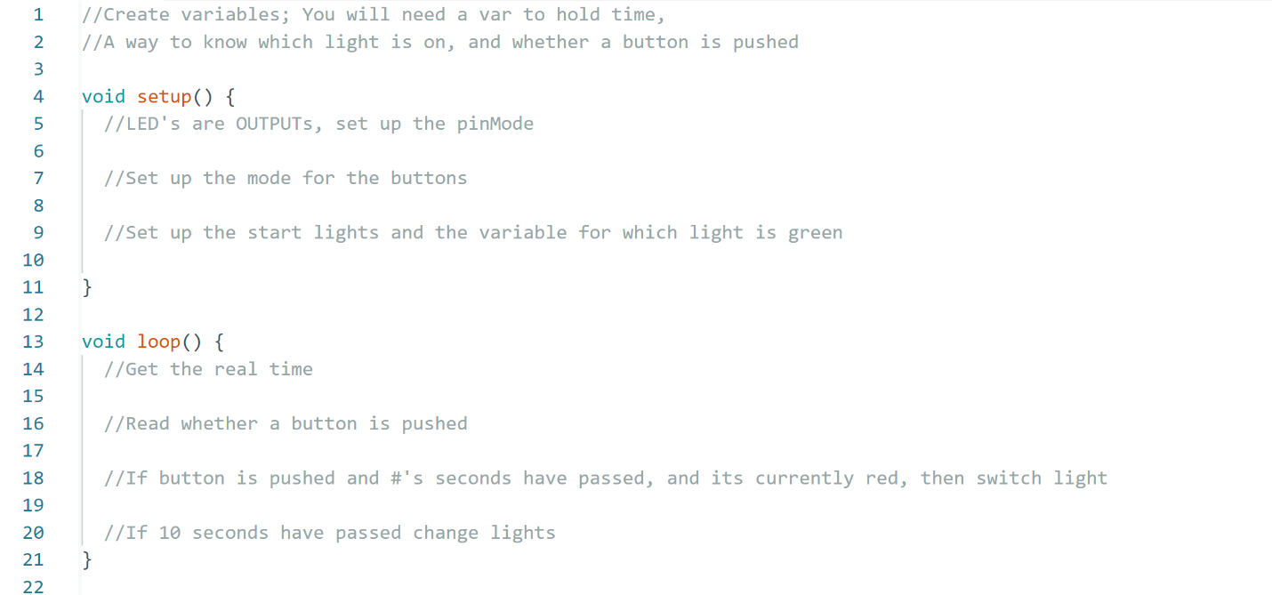
Requirements
- After 10 seconds, if there is no activity, the traffic lights will start changing.
- If a car arrives at a red light, the light should not change until it has been at least 3 seconds since the last light change
- Once the light starts changing there should be a 1 second delay from Yellow to Red; And the other light should have a 2 second delay from Red to Green.

Learning how to use a Multimeter
A multimeter is a versatile tool used to measure electrical properties such as voltage, current, and resistance. It combines the functions of a voltmeter, ammeter, and ohmmeter into one device, making it essential for diagnosing electrical issues and testing circuits. We use a multimeter to ensure the proper functioning of electrical components, identify faults, and verify the integrity of circuits, which is crucial in both troubleshooting and building electronic projects. Its ability to provide accurate measurements helps in maintaining safety and efficiency in electrical work. Please watch the video. We will ask you to use one as part of the comprehension questions.
https://www.youtube.com/watch?v=YdZfUEb9s-o

Lab 1 Code Appendix (in order of appearance):

int – Integers are your primary datatype for number storage. On the ELEGOO Uno an int stores a 16-bit (2-byte) value. This yields a range of -32,768 to 32,767

delay(time in milliseconds) - This command is used to pause a program and prevent it from updating conditions on the Arduino board for a specified amount of time. Note that the time entered is in milliseconds, not seconds.

millis() – reports how long the Arduino has been running (in milliseconds) since it was last powered on or reset

void setup() - This section of code runs once when the ELEGOO is powered up. It is typically used to configure the ELEGOO’s pins as inputs or outputs.

void loop() - This is where the main part of the program runs continuously. Inputs are checked and outputs are updated each time through the loop. Voltage inputs can be from devices such as switches, light sensors, and temperature sensors. Output voltage can be delivered to devices such as motors and lights.

pinMode(pin#, INPUT/OUTPUT) - This function requires an argument, so it knows which ELEGOO pin to configure. Pins can be configured as inputs or outputs.

digitalRead(pin#) - This function also requires an ELEGOO board pin number as an argument. It reads the HIGH (voltage present) or LOW (no voltage) digital state of the pin. The standard value for HIGH is ~5 volts while the standard value for LOW is ~0 volts. Numerically, a HIGH is considered 1 while a LOW is 0. This comes from the binary number system used by computers.

if() and else - These are commonly used decision-making statements in programming languages. if() requires arguments to determine whether a certain block of code should be executed. IF a given criteria is met, then the code within the brackets will be executed. For example, if the reading from an input is HIGH (meaning that there is a voltage), apply voltage to an output pin to turn on an LED. ELSE is a command that can only be used when preceded by another if() statement. If the original if() statement’s criteria are not met (i.e. the argument is false), then the block of code within the else statement will be executed instead. Using the previous example and adding an else statement, when the input pin reads LOW (instead of HIGH), there will be no voltage across the output pin.

digitalWrite(pin#, HIGH/LOW) - This function is the opposite of digitalRead(). It applies a voltage on the specified pin: HIGH (~5V) or LOW (~0V).

Serial.begin() - This command allows microcontroller to communicate with the computer. It requires an argument about which rate is at which data will be transferred.

Serial.print() - This command is used to tell the Arduino IDE serial monitor to print out data values coming from the microcontroller to the user.

Serial.println() – This command is similar to Serial.print() but after it is executed, any new Serial.print information will start a new line instead of printing on the same one.

Lab 1 Grading Rubric:
- Exercise #1 works (8.75 points)
- Exercise #2 works (8.75 points)
- Exercise #3 works (8.75 points)
- Exercise #4 works (8.75 points)
- Challenge Question (5 points)
- Comprehension Questions (10 points)

